# Learning Across Priors

## Content

During our investigation, we noticed that the frequency of the priors is not balanced, as shown in table 1 below. Specifically, each individual is randomly assigned priors with a 0.5 probability four times as often as prior 0.2 and prior of 0.8 independently. Similarly, priors of 0.3 and 0.7 are assigned twice as many times as priors of 0.2 and 0.8 independently.

We are curious whether the lower false report rates in figure 2b specific to prior belief of 0.5 are a result of learning given the repetition of priors. It is possible for participants to get a better understanding of the optimal strategy as they proceed in the experiment. Hence, priors with lower frequencies should exhibit a different distribution compared to priors that are shown multiple times.

Specifically, if there is learning involved, the rate of false reports for priors with single frequencies will be random across periods since a participant is assigned a prior randomly. On the contrary, the priors with multiple frequencies will see a gradual decrease in the false report rates as the games proceed. If an individual learns each time he/she is presented with the same scenario, then as the individual continues to get more exposure to prior 0.5 relative to the other priors, he/she will get better at giving answers regarding that prior, leading to a similar distribution in figure 2b in the paper.

In order to further understand the effect of learning or the lack of it, we replicate figure 2a for each prior for only the information treatment. Our hypothesis in this investigation is that considering some priors have a higher frequency than others, there will be some heterogeneous distributions of the distributions of each prior over periods.

Let's consider a scenario prior where participants encounter 0.5 four times. If there is learning among the participants causing them to reduce the false report rate, then the error rate for the priors of 0.5 will have an inverse relationship with periods. In contrast, for example, prior 0.2, prior 0.5 should look different. As a matter of fact, given the random assignment of the priors, there should not be a visible trend as the game proceeds if there is no learning. We present the result of these analyses below.

First, we present figure A, a replication of figure 2a in the original paper in the R programming language. As shown in figure A below, there is no trend as the game proceeds. Next, we present figure B. Figure B shows the Fraction of False Reports conditional on the prior probability being 0.2. Besides the lack of an obvious trend, the intervals for the prior of 0.2 are wide due to the low number of counts relative to other priors. The nature of the confidence intervals is similar to the priors of 0.8 in figure F, which, like 0.2, is shown 1 time to a participant.

Next, we look at the results of figures C and E together. Figure C shows the fraction of false reports conditioned on the prior probability being 0.2, and Figure E shows the fraction of false reports conditioned on the prior probability being 0.7. It is important to highlight that both priors – 0.3 and 0.7 occur randomly 2 times per participant. First, the range of the error bars reduces relative to those seen in figures A and F discussed above. Secondly, there is no trend in the false report rates across. In fact, errors increase beyond period 5 for prior 0.3 (Figure C), where it is more likely that participants have already been presented with the scenario.

Finally, we present the results of figure D. If there is learning conditional on the number of times a participant has experienced a scenario, it should be more obvious in this figure. Across the information treatment, each participant experiences the prior probability of 0.5 four times – 2 times as often as priors 0.7 and 0.3 and 4 times as often as priors 0.8 and 0.2. First, it is observed that the range of the error bars is lower as compared to the other priors due to the higher frequencies across rounds. Additionally, there is a trend before the midpoint of the game and after the midpoint. Before period 5, it is observed that the point false reports decrease as the game progresses. This is consistent with learning. However, the trend switches after period 5 where errors tend to increase with each additional period. Under the assumption that a larger portion of people seeing the prior of 0.5 at period 6 have experienced it compared to the participants seeing the same prior probability at period 5, there should be a lower false report, not higher as observed in figure D. This shows the learning observed in the first 5 periods is not consistent in the next 5 periods.

## Tables and Figures

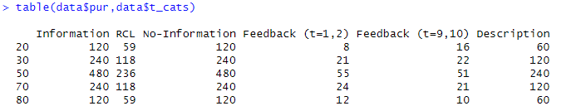

Table 1: Priors by Treatment Categories

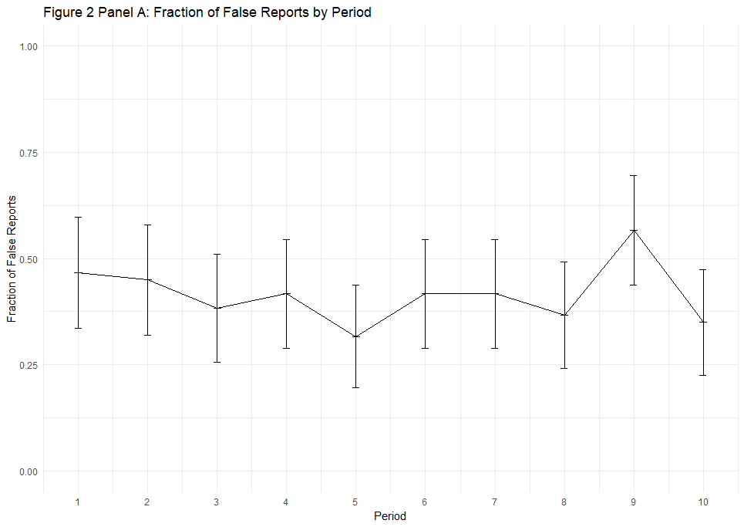

Figure A: Fraction of False Reports by Period

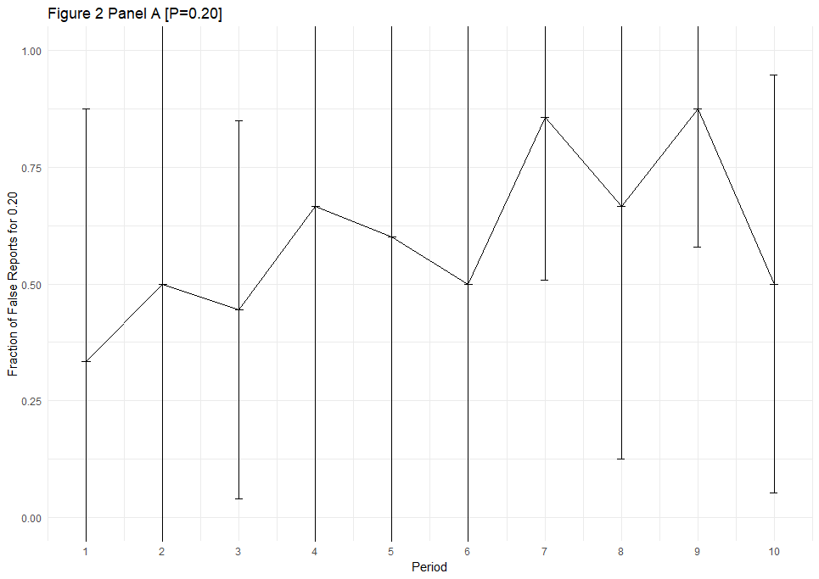

Figure B: Fraction of False Reports by Period Conditional on Prior Probability of 0.2

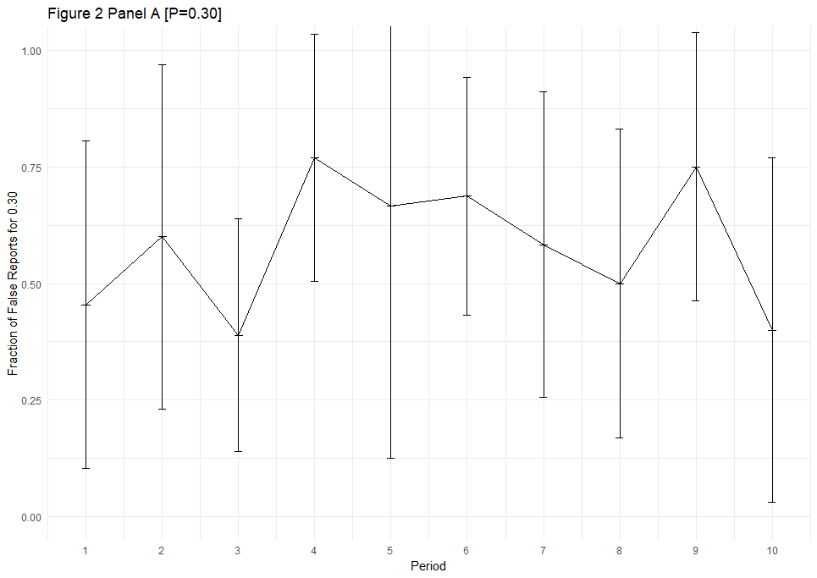

Figure C: Fraction of False Reports by Period Conditional on Prior Probability of 0.3

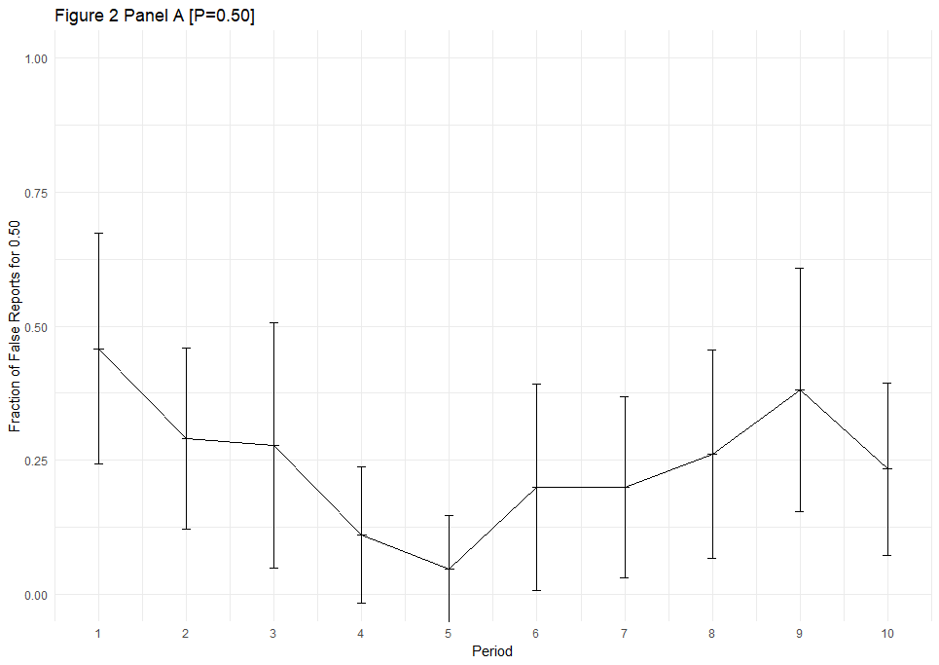

Figure D: Fraction of False Reports by Period Conditional on Prior Probability of 0.5

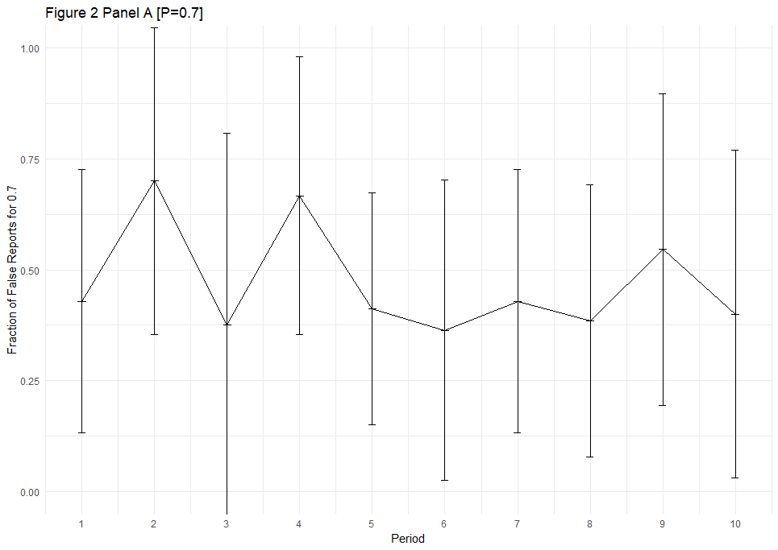

Figure E: Fraction of False Reports by Period Conditional on Prior Probability of 0.7

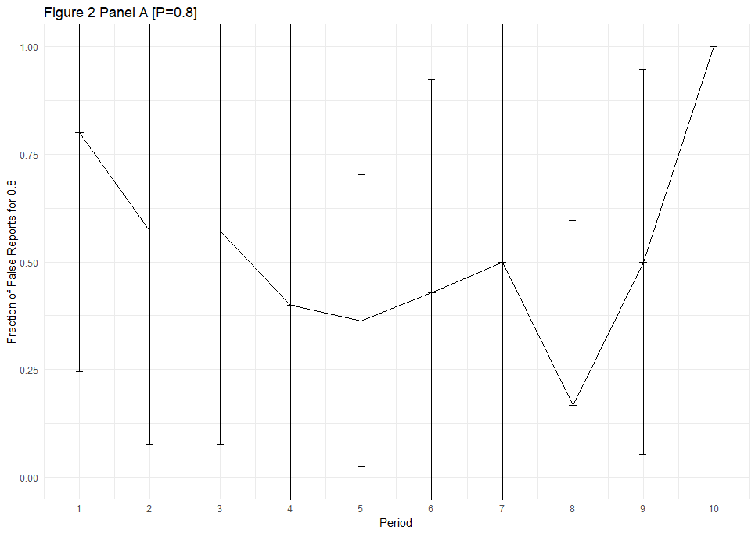

Figure F: Fraction of False Reports by Period Conditional on Prior Probability of 0.8